LAB # 07

**Objective :** To Understand Multithreading.

**Task:** Write the same code for matrix multiplication and divide the code into ten threads. Also note the timestamp at the start and end of the program. Give your conclusion.

**Matrix Multiplication Without Threading**

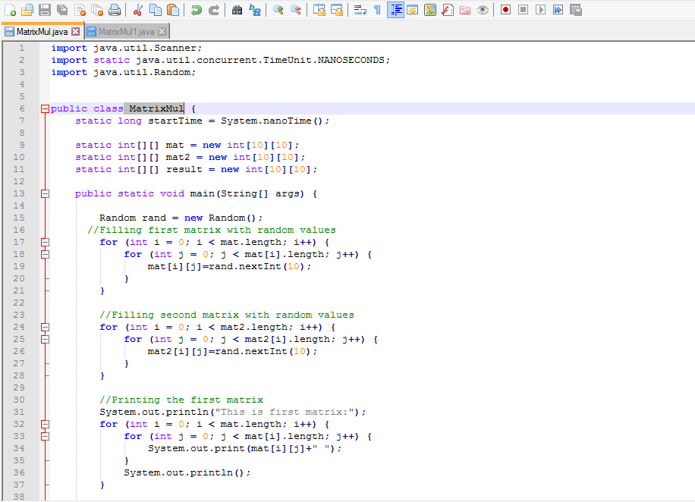

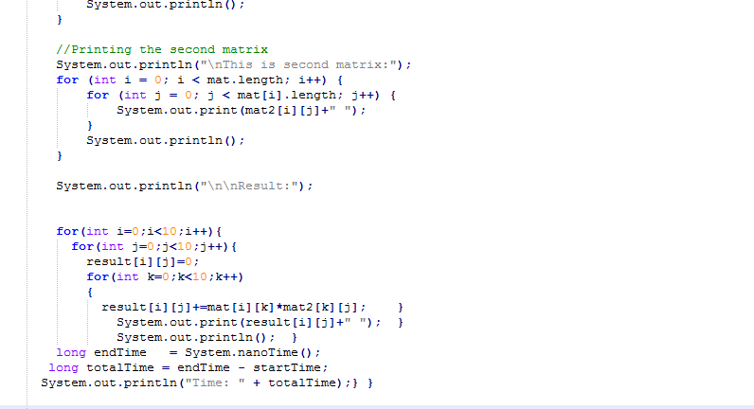

**Output:**

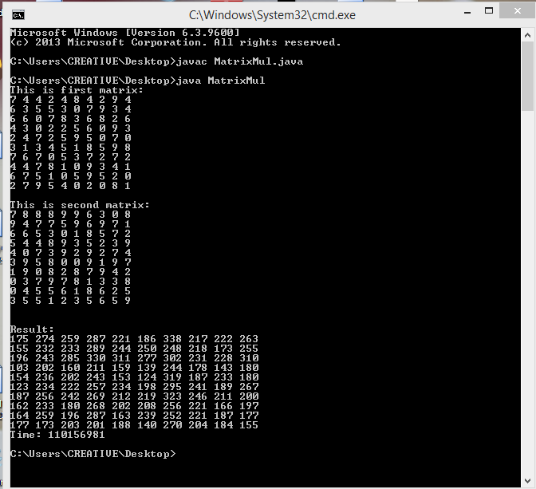

**Matrix Multiplication With Threading**

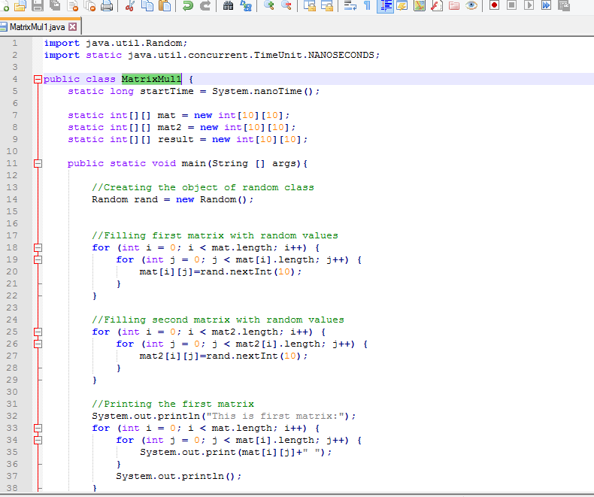

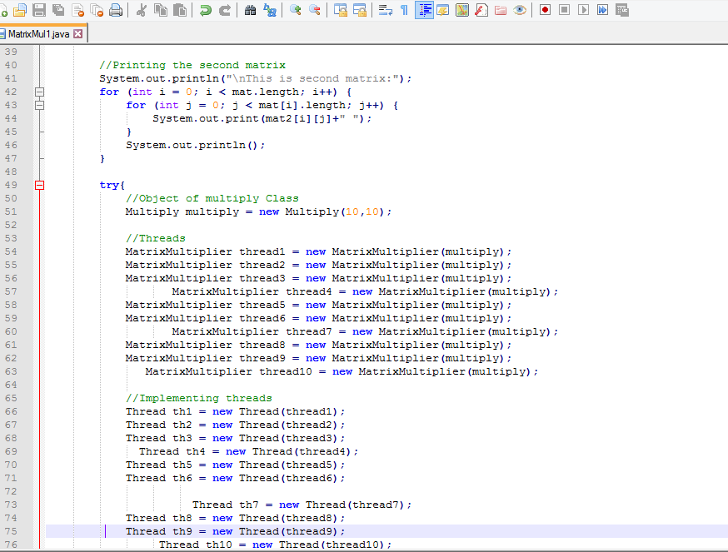

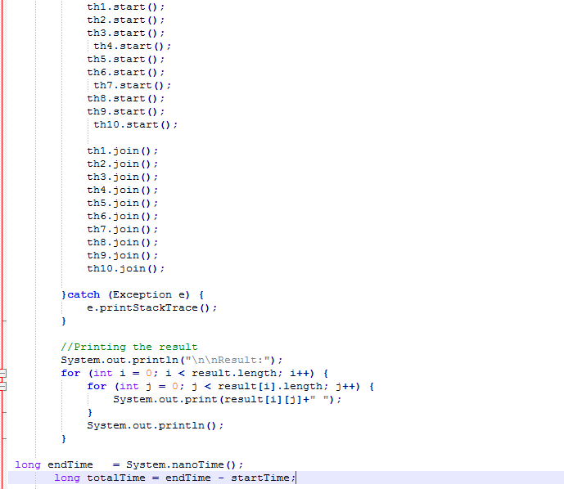

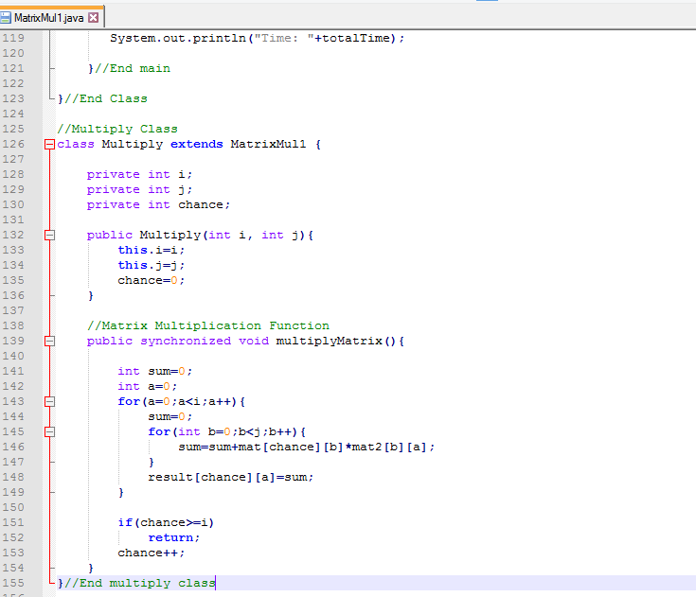

**Output**

